Tonight's Cast

Emcees Dan & Eddie
Trixie Amy
Frank N. Furter Diego
Brad Majors Bill
Janet Weiss Sammie
Riff Raff Steffan
Magenta Terry
Columbia Stezy
Dr. Scott Jesus
Eddie Tracy
Rocky Jason
Crim Leif
Phantom Dan

Transylvanians

Cheryl Poncho Andrew Peter
Carlos Kayla Jessika

Midnight Mafioso

Stage Director: Brandon Stage Director: Mandi Technical Director: Zac Inventory: Aleah
Tranny Coordinator: Cheryl Webmaster: Bill
Props Foxes: Jo Secretary: Aleah
Accountant: Kim Juu Photographers: Liz & Kate
House Managers: Tracy, Leif, & Drew
Security: Mark, Data, Fluffy, Jasmine, Wade
Merchandise: Aleah, Kat, Tayler
Spotlights: Kim, Lara, Christina, Nikkie, Kate, Brittany, Shasta
Scenic Tech: Zac, Mit, E van, Eddie, Siddell, Jesse

Denton Times
www.midnightinsanity.org
Buena tarde, senoras y caballeros!! Welcome to the real life telenovela that you all love so much, Midnight Insanity...or should I say, Locura de Medianoche!? Tonight we celebrate the fierceness of Mexican independence by partying down with some Cinco de Mayo flair. Be prepared for some exciting surprises, all presented en espanol. Enjoy!!

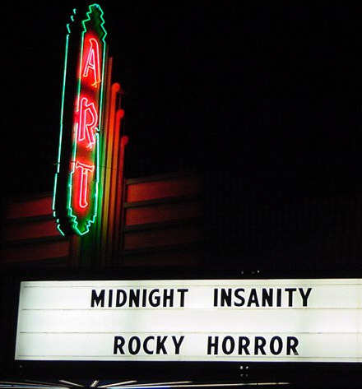
Midnight Insanity will be having a *very* special show on what just happens to be Friday the 13th. Come join us to support LifeCycle, a seven day bike ride from San Francisco to Los Angeles, that raises money to educate about HIV/AIDS, fund treatment, and continue working towards a cure. We will be performing at our old home, The Art Theater in Long Beach!!! Tickets are $15.00 (it's for charity, people) and can be purchased at www.arttheatrelongbeach.com. This is a one time only show, so you DON'T wanna miss it.

We've been getting so many requests for this next theme night, we HAD to plan it early. Be sure to clear your calendar for May 14th, because Midnight Insanity will be bringing back 80's Night!! That's right, come celebrate the decade that most of you were born in (or after...*sigh*)by whipping out the hairspray, pulling on the shoulder pads, and breaking out the neon. You GOTTA be here for this!!!

Have some suggestions for our show? Some merchandise you'd like us to sell? A prop that we should add to our stage? A performer you're hooked on and just HAVE to see more of? Then shoot an email to brandon@midnightinsanity.org OR mandi@midnightinsanity.org. Hope to hear from you lovely folks.

Brandon's Nonsensical Ramblings:
"You gotta put that extra stab in the heart of the chicken. Feel me?"

